  - Please complete and return this commissioning form within 14 days of commissioning.


The commissioning form should be returned along with the following documentation:

- Photo image of the installed heat pump and local area (1m around the unit)
- Wiring schematic as installed
- Pipe work schematic as installed

Section 1. Pre-commissioning
(Air cooled heat pump mono-block products)

Installer’s details name and address: | Site address:
Installers contact details, telephone No: and email:
Date equipment was installed. | Date equipment was commissioned.
Equipment details:
Model WiSAN-YME | Refrigerant type and quantity
Size? 2.1 3.1. 4.1. 5.1. 6.1. 7.1. 8.1 | (see data plate label)
Serial No
(See data plate label or white bar code label)
Ancillaries if supplied with unit
Pre-operational checks | Additional notes:
Damage to equipment/ refrigerant leakage?
Location - suitable space around the unit
Clearance to rear - M
Clearance to front - M
Clearance to left - M
Clearance to right - M
Distance to other buildings/windows M
Ambient sensor (check if subject to sun/wind?) Yes/No
Unit correctly mounted, AV mounts? Yes/No
Condensate drain suitable? Yes/No
Electrical power to unit and correctly installed?
Site voltage at unit V
Electrical isolation Yes/No
Electrical protection Yes/No
Cables correct Yes/No
Water side installation
Water strainer must be installed Yes/No
Low loss header / buffer tank installed Yes/No
Buffer tank volume (> than min water vol?) lt
Water flow measurement device? Yes/No
Water flow rate l/s
Isolation valves on flow/return Yes/No
Flexible connections on flow/return Yes/No
Expansion vessel sized for system lt
Water quality checked (inhibitors/Glycol?) %
Pipes insulated/protected for low ambient Yes/No
Air purged from system Yes/No
DHW T5 sensor fitted and secured Yes/No
T1 sensor fitted after IBH/AHS (option) Yes/No
System Installation completed Yes/No
DHW valve wired (DHW/heating) Yes/No
Wall controller fitted and wired Yes/No
Thermostats fitted and wired (option) Yes/No
Mode change / one zone / 2 Zone.
Remote on/off Yes/No
AHS Additional heat source (dip switch) Yes/No
TBH DHW heater (dip switch) Yes/No
Pd Pump Yes/No
IBH Back up heater Yes/No
Mixing valve + PC +P_C Yes/No
Ensure power connected 24 your prior commissioning (crank case heaters on) Yes/No

Section 2. Commissioning
(Air cooled heat pump mono-block products)

Please record all parameter changes made during the commissioning.
It is mandatory to check/correct those in highlighted yellow. Enabling functions may open up associated parameter menus or disable menus.

DHW mode settings |  | Default | Commissioned
1.1 DHW MODE | Enable or disable the DHW mode NO/YES | YES
1.2 DISINFECT | Enable or disable the disinfect mode NO/YES | YES
1.3 DHW PRIORITY | Enable or disable the DHW priority mode NO/YES | YES
1.4 DHW PUMP | Enable or disable the DHW pump mode NO/YES | NO
1.5 DHW PRIORITY TIME SET | Enable or disable the DHW priority time set NO/YES | NO
1.6 dT5_ON | The temperature difference for starting the heat pump | 10 °C
1.7 dT1S5 | The correct value to adjust the output of the compressor | 10 °C
1.8 T4DHWMAX | The maximum ambient temperature that the heat pump can operate at for domestic water heating | 43 °C
1.9 T4DHWMIN | The minimum ambient temperature that the heat pump canoperate for domestic water heating | -10 °C
1.10 t_INTERVAI_DHW | the start time interval of the compressor in DHW mode | 5 MIN
1.11 dT5_TBH_ OFF | the temperature difference between T5 and T5S that  turns the booster heater off | 5 °C
1.12 T4_TBH_ON | the highest outdoor temperature the TBH can operate | 5 °C
1.13 t_TBH_DELAY | the time that the compressor has run before starting the boost heater | 30 Min
1.14 T5S_DI | the target temperature of water in the domestic hot water tank in the Disinfect function | 65 °C
1.15 t_DI_HIGHTEMP | the time that the highest temperature of water in the  domestic hot water tank in the DISINFECT function will last | 15 MIN
1.16 t_DI_MAX | the maximum time that disinfection will last | 210 MIN
1.17 t_DHWHP_RESTRICT | the operation time for the space heating/cooling operation | 30 MIN
1.18 t_DHWHP_MAX | the maximum continuous working period of the heat pump in DWH priority mode | 90 MIN
1.20 PUMP RUNNING TIME | the time that the DHW pump will keep running for | 5 MIN
1.19 DHW PUMP TIME RUN | Enable or disable the DHW pump run as timed and keeps running for pump run time NO/YES | YES
1.21 DHW PUMP DISINFECT | Enable or disable the DHW pump operate when the unit is in disinfect mode and T5≥T5S_DI-2 NO/YES | YES

Cooling Mode Settings |  | Default | Commissioned
2.1 COOL MODE | Enable or disable the cooling mode NO/YES | YES | NO

Heating Mode Settings |  | Default | Commissioned
3.1 HEAT MODE | Enable or disable the heating mode | YES
3.2 t_T4_FRESH_H | Refresh time of climate related curves for heating mode | 0.5 hours
3.3 T4HMAX | Max ambient operating temperature for heating mode | 25 °C
3.4 T4HMIN | Min ambient operating temperature for heating mode | -15 °C
3.5 dT1SH | The temperature difference for starting the unit (T1) | 5 °C
3.6 dTSH | The temperature difference for starting the unit (Ta) | 2 °C
3.7 t_INTERVAL_H | The compressor start time interval | 5 MIN
3.8 T1SETH1 | Temperature 1 of climate related curves for heat mode | 35 °C
3.9 T1SETH2 | Temperature 2 of climate related curves for heat mode | 28 °C
3.10 T4H1 | Temperature 1 of climate related curves for heat mode | -5 °C
3.11 T4H2 | Temperature 2 of climate related curves for heat mode | 7 °C
3.12 ZONE1 H-EMISSION | The type of zone 1 for heating mode：FCU(fan coil unit), RAD (radiator), FLH (floor heating) | RAD
3.13 ZONE2 H-EMISSION | The type of zone 2 for heating mode：FCU(fan coil), RAD(radiator), FLH (floor heating). | FLH
3.14 t_DELAY_PUMP | Time that the compressor has run before starting the pump | 2 MIN

Auto Mode Settings |  | Default | Commissioned
4.1 T4AUTOCMIN | Min ambient temperature for cooling in auto mode | 25 °C
4.2 T4AUTOHMAX | Maximum ambient temperature for heating in auto mode | 17 °C

Temp Type Settings |  | Default | Commissioned
5.1 WATER FLOW TEMP | Enable WATER FLOW TEMP NO/YES | YES
5.2 ROOM TEMP | Enable ROOM TEMP NO/YES | NO
5.3 DOUBLE ZONE | Enable ROOM THERMOSTAT DOUBLE ZONE NO/YES | NO

Temp Type Settings |  | Default | Commissioned
6.1 ROOM THERMOSTAT | Room thermostat No, Mode set, 1 zone, 2 zone | No

Other Heat Source Settings |  | Default | Commissioned
7.1 dT1_IBH_ON | Temp diff between T1S and T1 for starting backup heater | 5 °C
7.2 t_IBH_DELAY | Compressor run time before first backup heater starts | 30 MIN
7.3 T4_IBH_ON | Ambient temperature for starting the backup heater | -5 °C
7.4 dT1_AHS_ON | Temp diff between T1S and T1B to start additional heat source | 5 °C
7.5 t_AHS_DELAY | Comp run time before starting the additional heat source | 30 MIN
7.6 T4_AHS_ON | The ambient temperature for starting the additional heat Source | 10 °C
7.7 IBH_Locate | IBH/AHS Installation location pipe loop | Pipe
7.8 P_IBH1 | Power input of IBH1 | 0.0kw
7.9 P_IBH2 | Power input of IBH2 | 0.0kw
7.10 P_TBH | Power input of TBH | 2.0kw

Holiday Away Settings |  | Default | Commissioned
8.1 T1S_H.A_H | The target outlet water temperature for space heating | 25 °C
 | when in holiday away mode
8.2 T5S_H.A_DHW | The target outlet water temperature for domestic hot | 25 °C
 | water heating when in holiday away mode

Auto Restart Settings |  | Default | Commissioned
13.1 AUTO RESTART COOL/HEAT MODE | Enable auto restart cooling/heating mode NO/YES | YES
13.2 AUTO RESTART DHW MODE | Enable or disable the auto restart DHW mode NO/YES | YES

Power Input Settings |  | Default | Commissioned
14.1 POWER INPUT LIMITATION | The type of power input limitation 0=NO 1-8 Setting | 0

Input Settings |  | Default | Commissioned
15.1 ON/OFF (M1 M2) | Define the function of the M1 M2 switch.  REMOTE ON/OFF, TBH ON/OFF, AHS ON/OFF | Remote
15.2 SMART GRID | Enable or disable the SMART GRID. NO, YES | No
15.3 T1b (TW2) | Enable or disable the T1b (TW2). NO, YES | No
15.4 Tbt1 | Enable or disable the Tbt1, NO, YES | No
15.5 Tbt2 | Enable or disable the Tbt2, NO, YES | No
15.6 Ta | Enable or disable the Ta (HMI, IDU) | HMI
15.7 Ta-adj | The correction value for Ta on the wired controller | -2
15.8 Solar Input | Type of Solar input, No, Tsolar, 1SL 1SL2 | No
15.9 F-Pipe length | Total length of the liquid pipe (F-Pipe length) less than 10m, more than 10m | < 10M
15.10 RT/Ta_PCB | Enables disables the RT/Ta_PCB, NO, YES | No
15.11 Pump I silent mode | Enables or disables Pump I silent mode, No, Yes | No

Input Settings |  | Default | Commissioned
16.1 PER_START | Start up % with multiple units | 10 %
16.2 TIME_ADJUST | Adjustment time for adding and subtracting units | 5 MIN
16.3 ADDRESS RESET | Reset the address code of the unit 0-15 | FF

Input Settings |  | Default | Commissioned
17.1 HMI SET | Master, Slave | Master
17.2 HMI address for BMS | HMI address for the BMS 1-16 | 1

Once the unit is operating in a stable way under full load (approx. 20 minutes of compressor running time) record the operating parameter values shown in controller menu. Record for all operating modes if applicable/configured (i.e. Heating, DHW, Cooling).

Operating mode | Heating | DHW | Cooling
Online units number
Operating mode
SV1 State
SV2 State
SV3 State
Pump_I
Pump_O
Pump_C
Pump_S
Pump_D
Pipe backup heater
Tank backup heater
Gas boiler
T1 leaving water temp
Water flow
Heat pump capacity
Power consumed
Ta Room Temp
T5 Water tank temp
Tw2 circuit2 water temp
T1S' C1 Cli curve temp
T1S2' C2 Cli curve temp
TW_O Plate W-Outlet Tem
TW_I Plate W-Inlet Temp
Tbt1 Buffertank_Up Temp
Tbt2 Buffertank_Low Temp
T solar
IDU Software
ODU Model
Comp Current
Comp Frequency
Comp run time
Comp total run time
Expansion Valve

Fan Speed
IDU Target Frequency
Frequency Limited Type
Supply Voltage
DC Generatrix Voltage
DC Generatrix Current

TW_O Plate W_Outlet Tem
TW_I Plate W_Inlet Temp
T2 Plate F-Out Temp
T2B Plate F-In Temp
Th Comp Suction Temp
Tp Comp Discharge Temp

T3 Outdoor Exchanger Tem
T4 Outdoor Air Temp
TF Module Temp
P1 Comp Pressure
ODU Software
HMI Software

Check and record all hard-wired connections that have been made during the installation. The most common options are shown below: please tick those that have been installed

Main wiring options, please indicate if used in your system

- Domestic hot water valve connection wired? ______________________________________

Ensure T5 sensor fitted in DHW tank
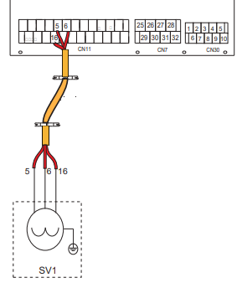
Page 44

- Domestic hot water pump wired (via customer supplied contactor)? ________________

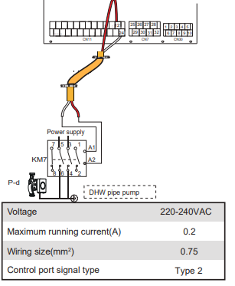
Page 45

- DHW Tank backup heater wired (via customer supplied contactor)?_________________

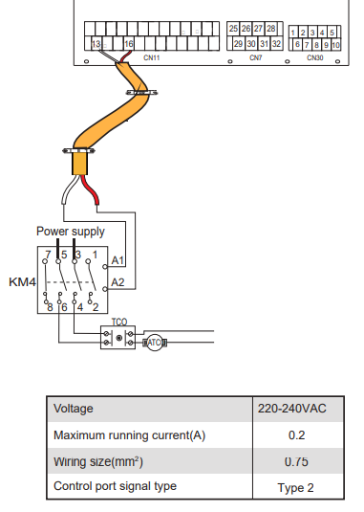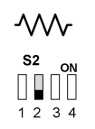
Page 47 & 49

- Has the single zone thermostat connection been wired and activated in the menu? ______

This will ensure the heat mode stops when there is no demand for heating.

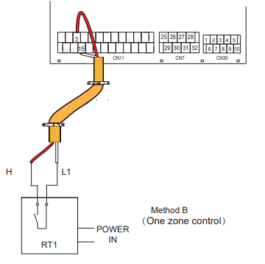

- Boiler integrated within system?___________________________________________

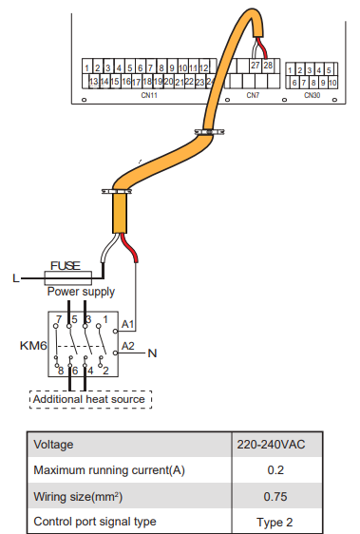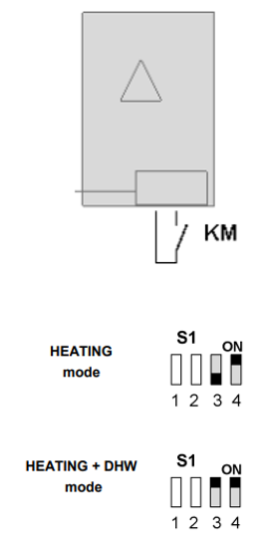

Has the T1 (separately supplied sensor option) been installed
(required when using an additional heat source AHS)?_________________________________

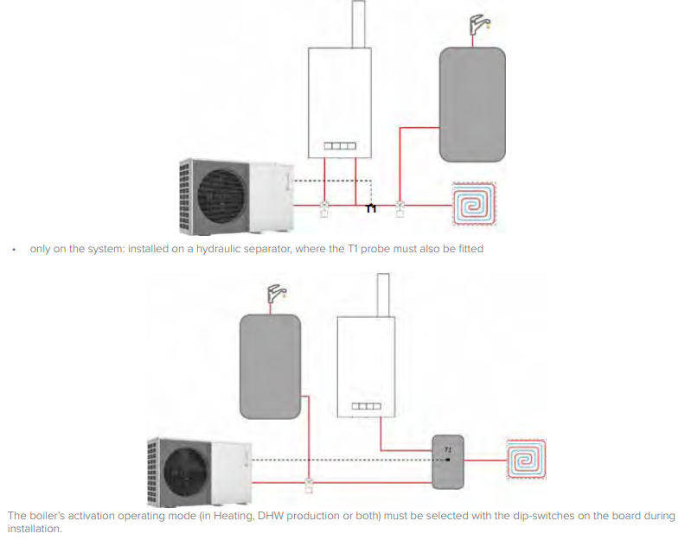

Pages 47 and 49

